FSDI 107 – Final Report
Name: Charles Taggart
Theme: Final Report
GitHub Pages Link: https://github.com/chucktagg83/project107.git
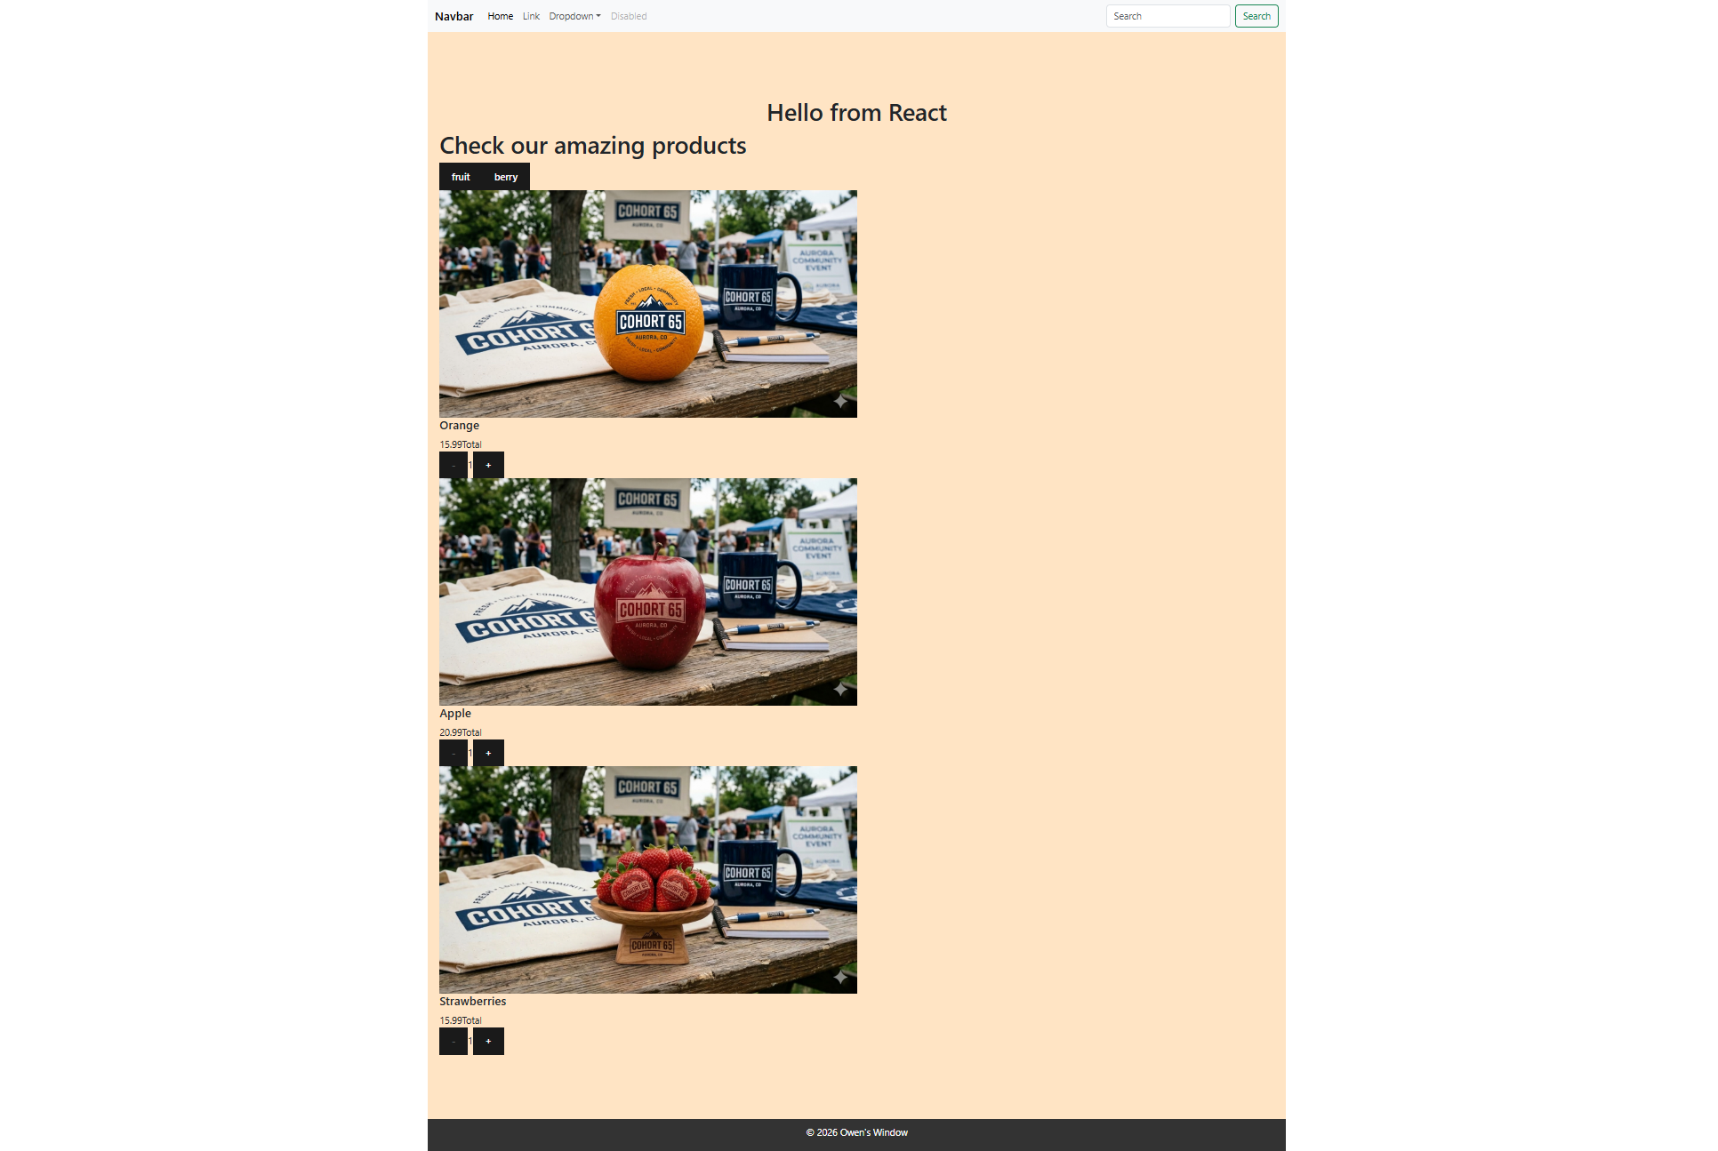

Summary of Edits:
- Full page view
- Page css consists of background color change, visible scrolling added, responsiveness
- Product displayed with title, quantitypicker, fruit/berry tabs.
- Also below is the responsiveness shown.